**PERFORMANCE REPORT**

**After running each test you have to repopulate the database .**

All the performance test has been executed in the Developer VM with the next configuration:

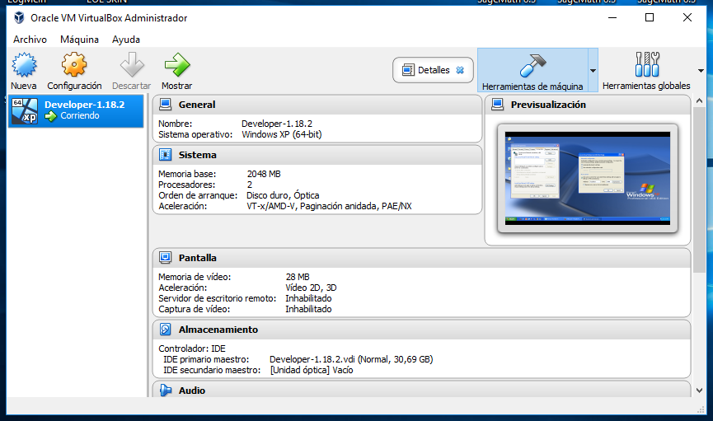

We have to set the proxy configuration as the following picture to run the test in the Developer VM:

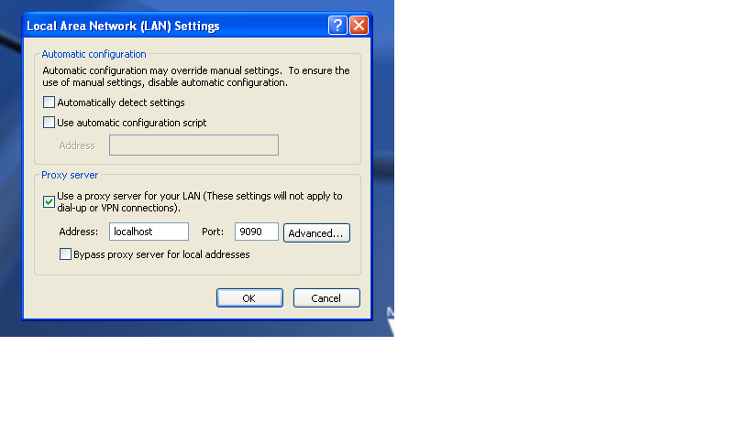

REGISTER ADMINISTRATOR TEST (UC 11.1)

In this test we performance the creation of new administrators in the system. The test consists of 10 threads (user) doing 10 loops, these are the results.

AGGREGATE REPORT

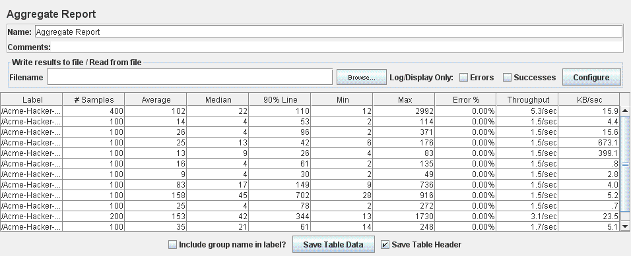

GRAPH RESULT

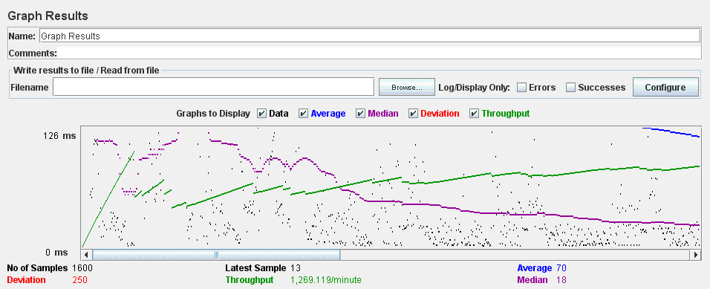

REGISTER COMPANY TEST (UC 7.1)

In this test we performance the creation of new companies in the system. The test consists of 10 threads (user) doing 10 loops, these are the results.

AGGREGATE REPORT

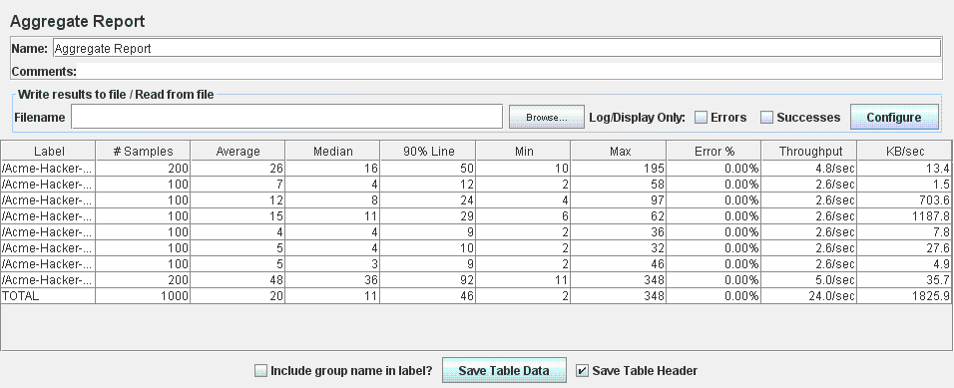

GRAPH RESULT

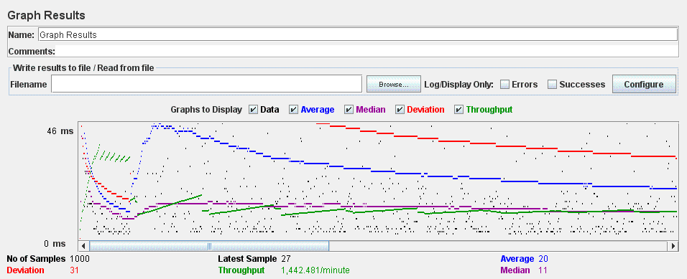

REGISTER HACKER TEST (UC 7.1)

In this test we performance the creation of new hackers in the system. The test consists of 10 threads (user) doing 10 loops, these are the results.

AGGREGATE REPORT

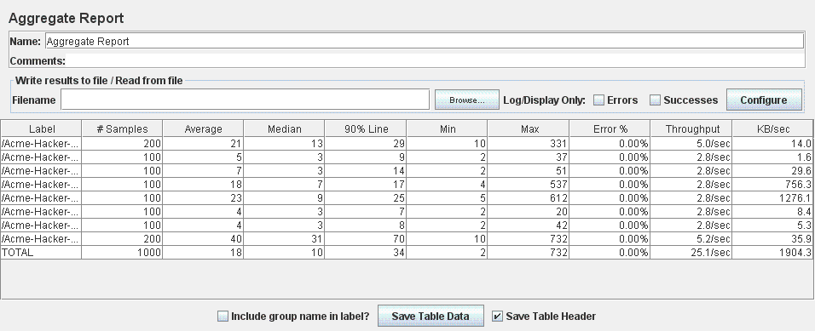

GRAPH RESULT

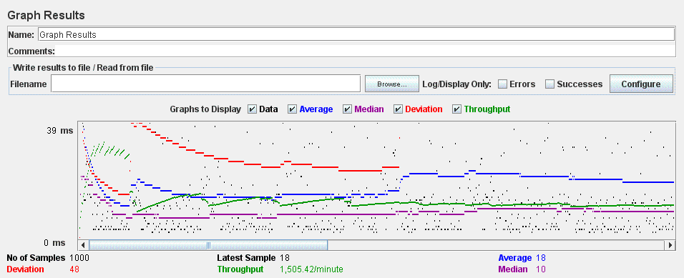

EDIT PERSONAL DATA ADMINISTRATOR TEST (UC 8.2)

In this test we performance the edition of the administrator personal data. The test consists of 10 threads (user) doing 10 loops, these are the results.

AGGREGATE REPORT

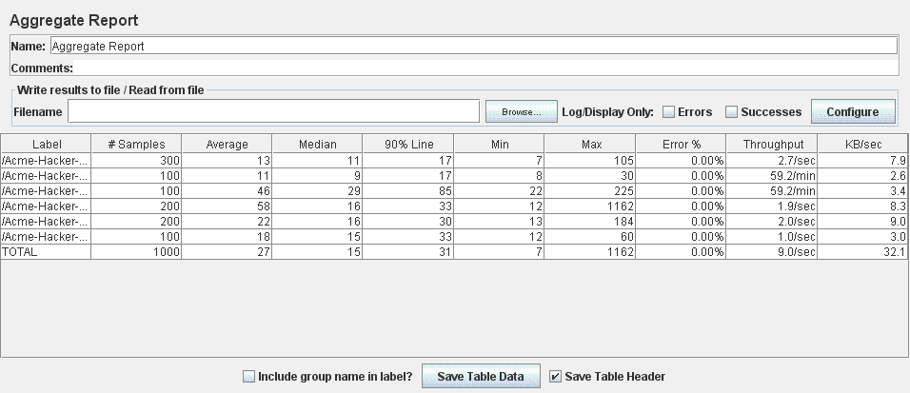

GRAPH RESULT

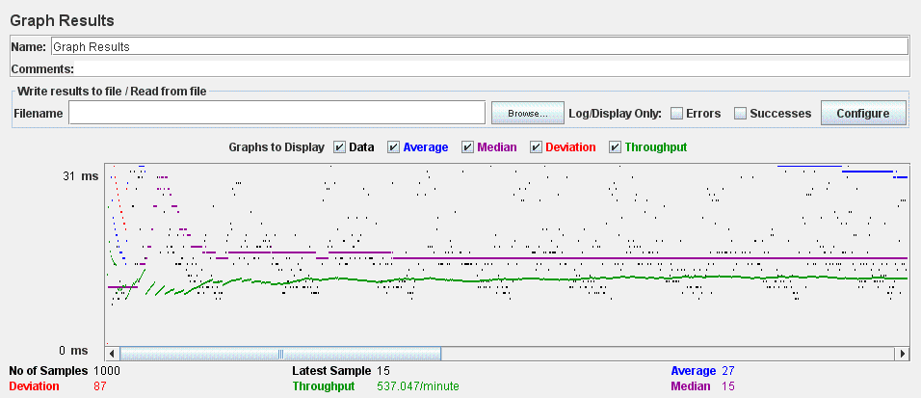

EDIT PERSONAL DATA COMPANY TEST (UC 8.2)

In this test we performance the edition of the company personal data.The test consists of 10 threads (user) doing 10 loops, these are the results.

AGGREGATE REPORT

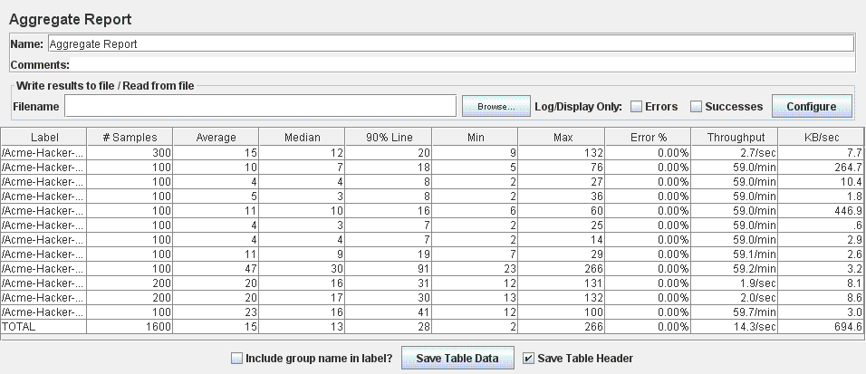

GRAPH RESULT

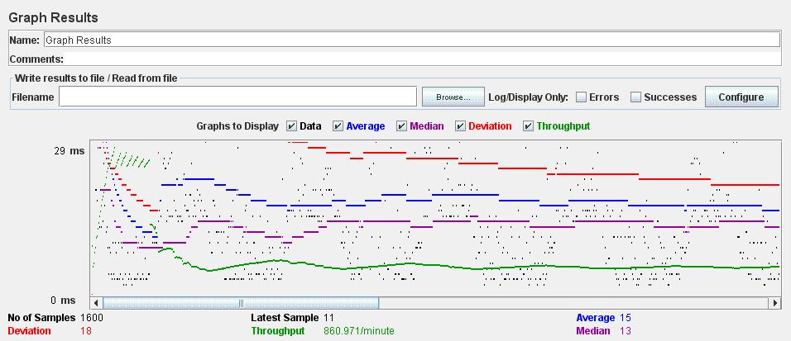

EDIT PERSONAL DATA HACKER TEST (UC 8.2)

In this test we performance the edition of the hacker personal data.The test consists of 10 threads (user) doing 10 loops, these are the results.

AGGREGATE REPORT

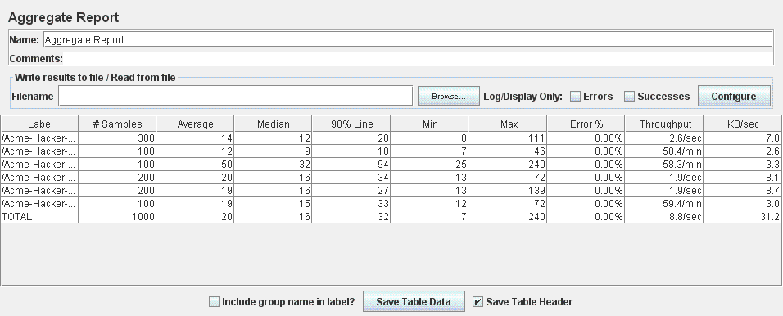

GRAPH RESULT

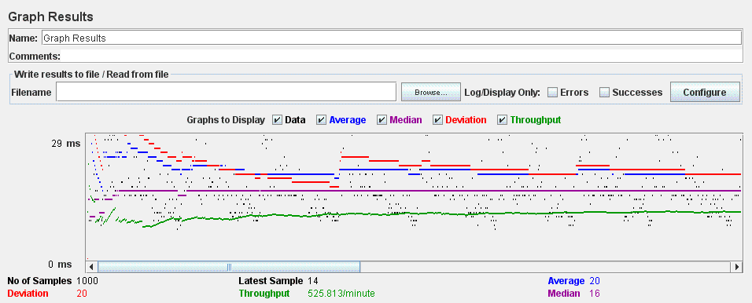

LIST COMPANIES NOT LOGGED TEST (UC 7.3)

In this test we performance the list of companies as a not logged actor. The test consists of 10 threads (user) doing 10 loops, these are the results.

AGGREGATE REPORT

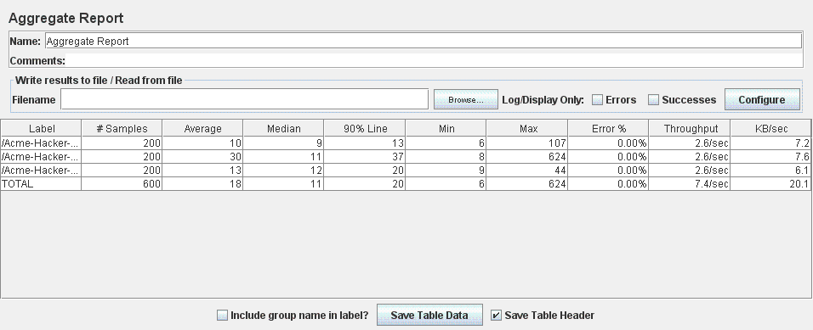

GRAPH RESULT

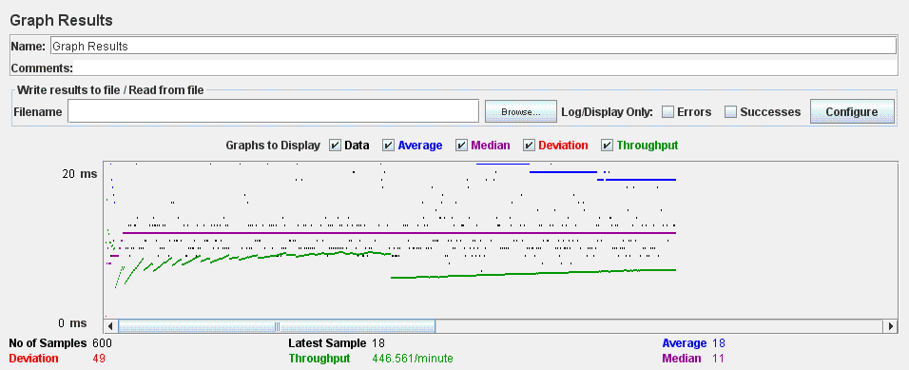

LIST NOT LOGGED POSITION TEST (UC 7.2)

In this test we performance the list of positions as a not logged actor. The test consists of 10 threads (user) doing 10 loops, these are the results.

AGGREGATE REPORT

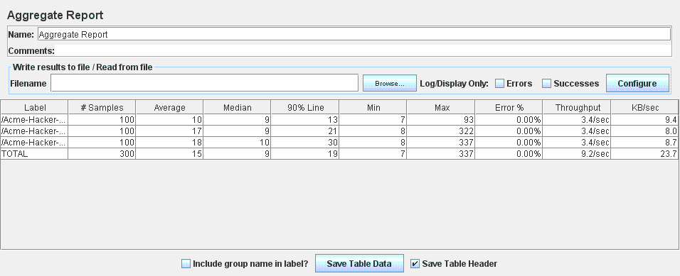

GRAPH RESULT

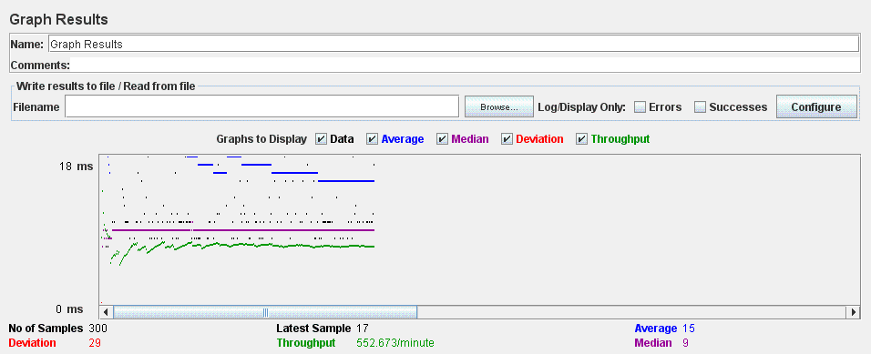

SEARCH FINDER NOT LOGGED TEST (UC 7.4)

In this test we performance the finder of positions as a not logged actor. The test consists of 10 threads (user) doing 10 loops, these are the results.

AGGREGATE REPORT

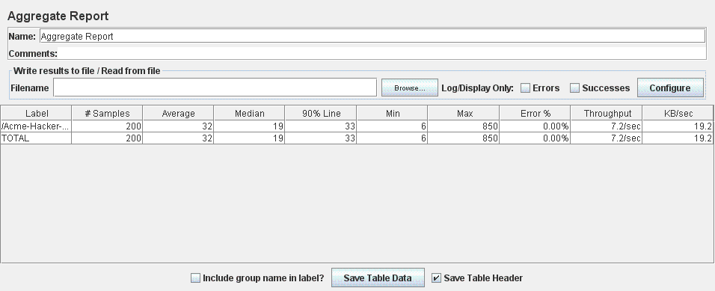

GRAPH RESULT

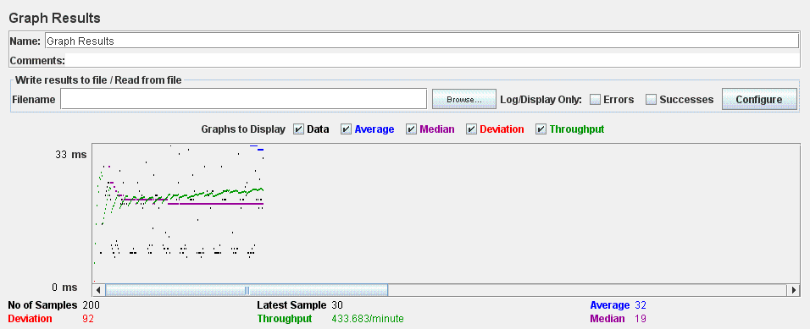

SOCIAL PROFILE TEST (UC 23.1)

In this test we performance the list, create, update, show and delete of a social profile of an actor. The test consists of 10 threads (user) doing 10 loops, these are the results.

AGGREGATE REPORT

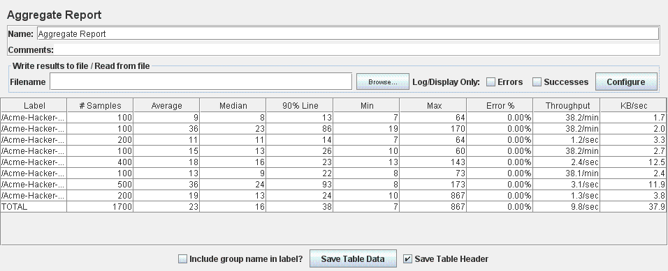

GRAPH RESULT

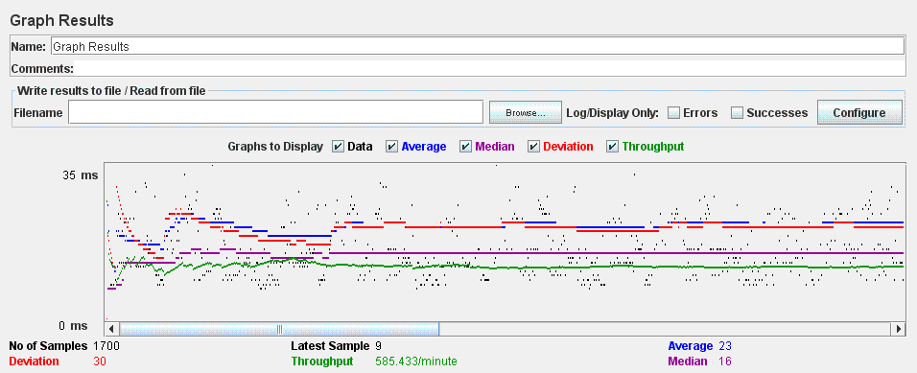

CURRICULA TEST (UC 17.1)

In this test we performance the list, create, update, show and delete of all types of curricula and their data. The test consists of 10 threads (user) doing 10 loops, these are the results.

AGGREGATE REPORT

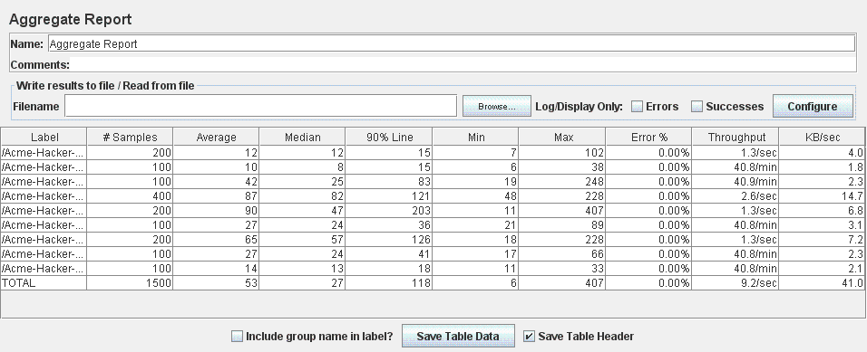

GRAPH RESULT

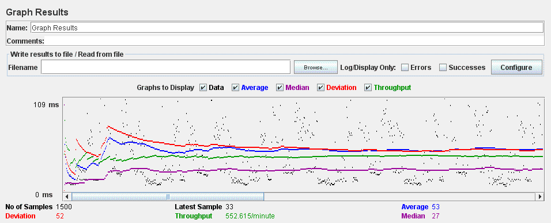

POSITION TEST (UC 9.1)

In this test we performance the creation, edit, save as draft/final, delete, cancel and show of positions. The test consists of 10 threads (user) doing 10 loops, these are the results.

AGGREGATE REPORT

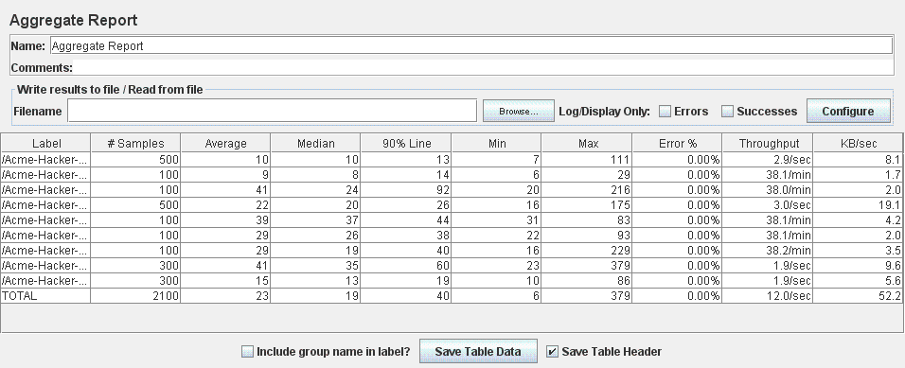

GRAPH RESULT

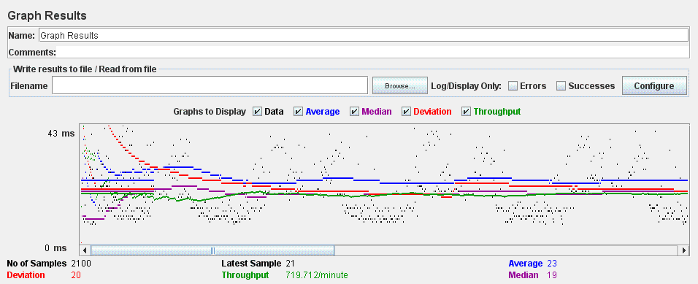

MANAGE PROBLEM TEST (UC 9.2)

In this test we performance the list, create, update, delete and show of problems. The test consists of 10 threads (user) doing 10 loops, these are the results.

AGGREGATE REPORT

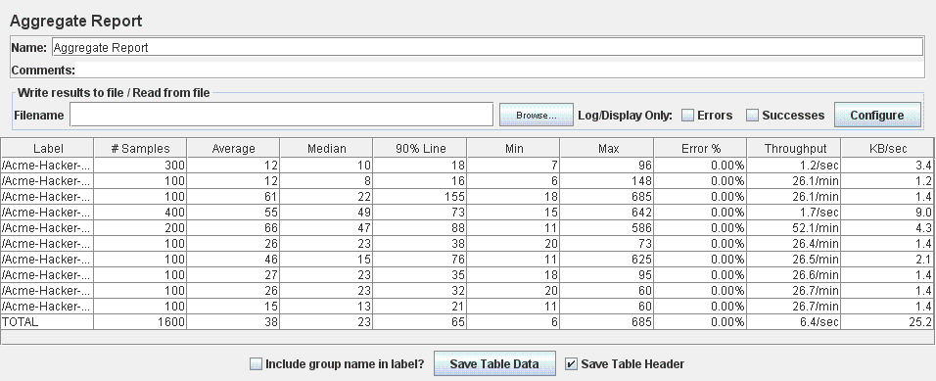

GRAPH RESULT

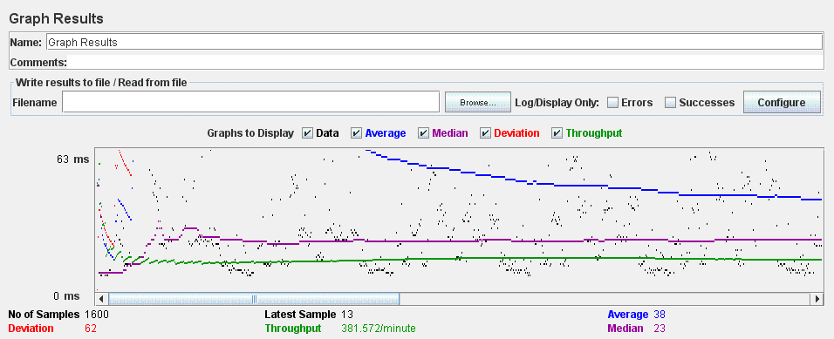

MANAGE MESSAGE TEST (UC 23.2)

In this test we performance the list, creation, show and delete of messages. The test consists of 10 threads (user) doing 10 loops, these are the results.

AGGREGATE REPORT

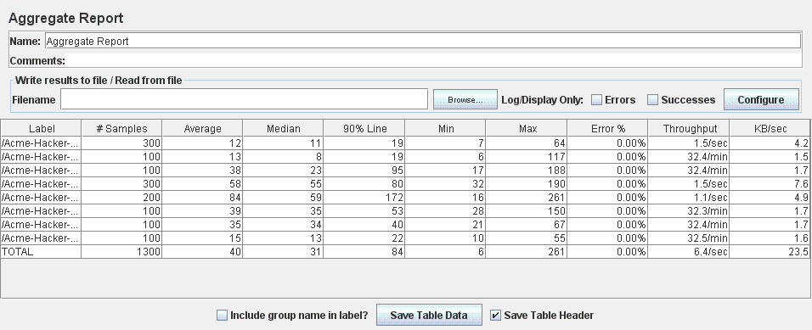

GRAPH RESULT

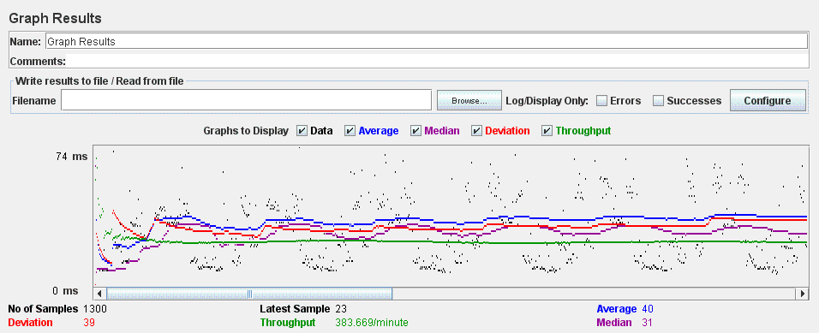

BROADCAST TEST (UC 24.1)

In this test we performance the broadcast of a message by an administrator. The test consists of 10 threads (user) doing 10 loops, these are the results.

AGGREGATE REPORT

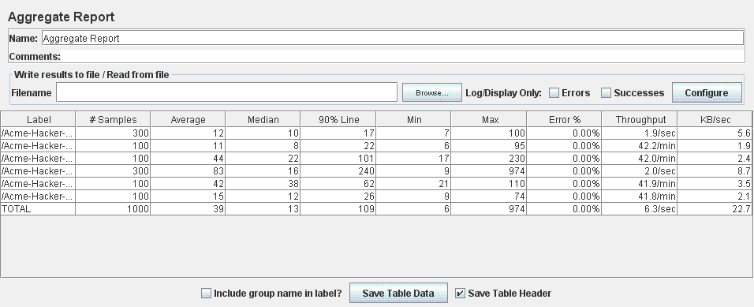

GRAPH RESULT

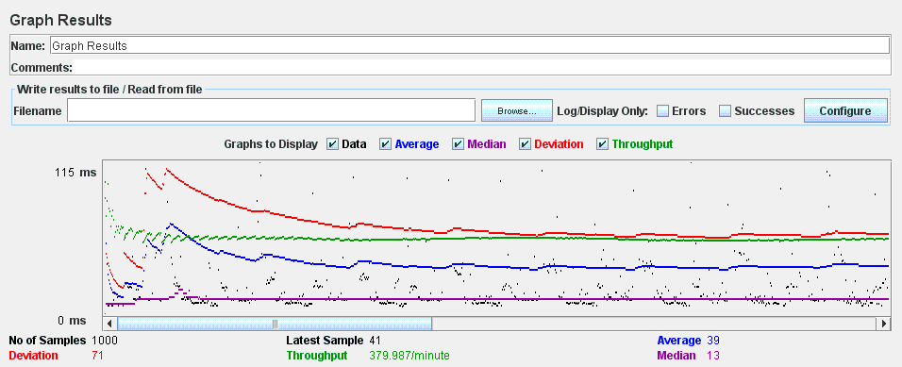

SPAM, BAN AND UNBAN TEST (UC 24.2, 24.3, 24.4)

In this test we performance the process to calculate spammers, ban and unban users. The test consists of 10 threads (user) doing 10 loops, these are the results.

AGGREGATE REPORT

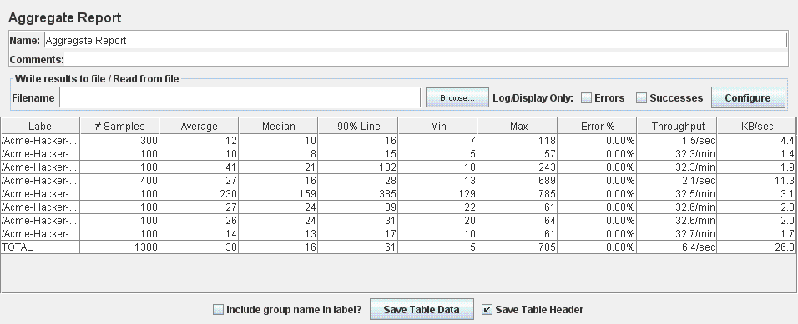

GRAPH RESULT

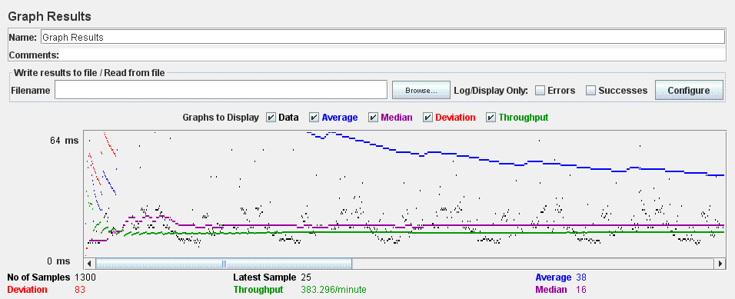

DASHBOARD TEST (UC 11.2, 18.1)

In this test we performance of the administrator dashboard. The test consists of 10 threads (user) doing 10 loops, these are the results.

AGGREGATE REPORT

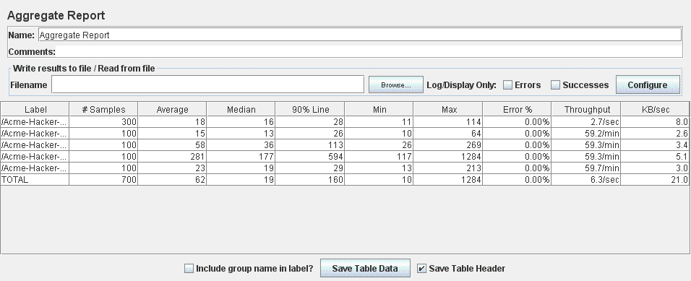

GRAPH RESULT

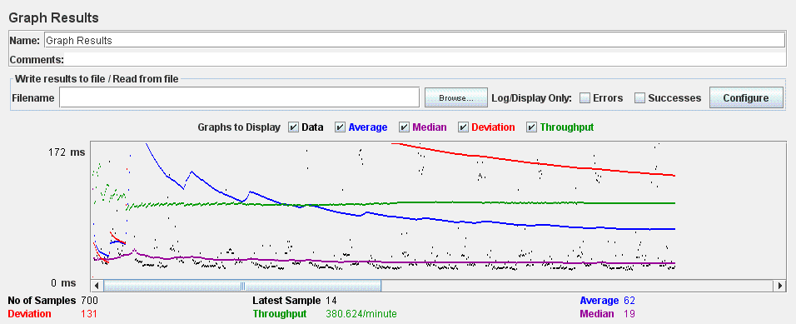

LIST, CREATE AND UPDATE APPLICATION TEST (UC 10.1)

In this test we performance the list, creation and updating applications. The test consists of 10 threads (user) doing 10 loops, these are the results.

AGGREGATE REPORT

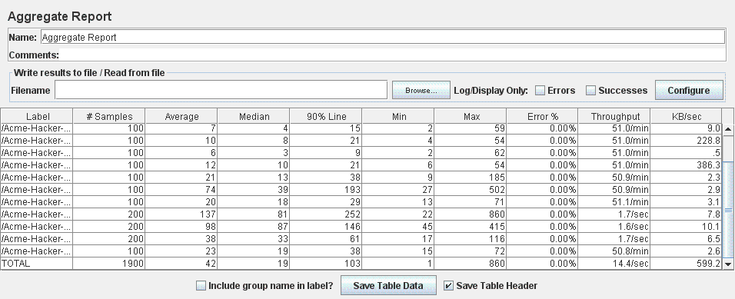

GRAPH RESULT

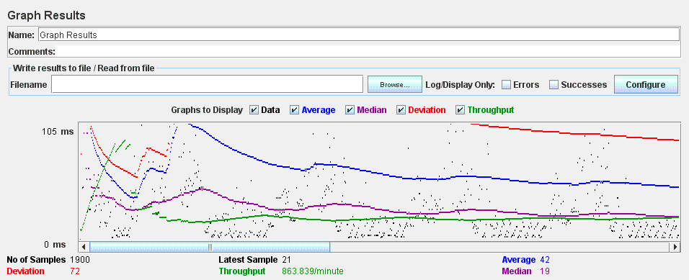

ACCEPT APLICATION TEST (UC 9.3)

In this test we performance the action of accept an application. The test consists of 10 threads (user) doing 10 loops, these are the results.

AGGREGATE REPORT

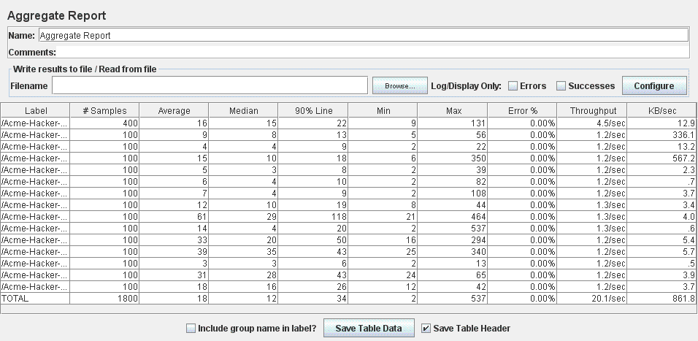

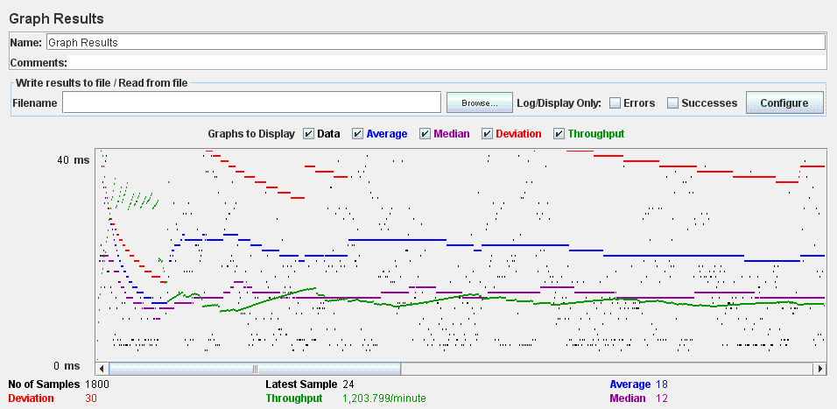GRAPH RESULT

REJECT APPLICATION TEST (UC 9.3)

In this test we performance the action of reject an application. The test consists of 10 threads (user) doing 10 loops, these are the results.

AGGREGATE REPORT

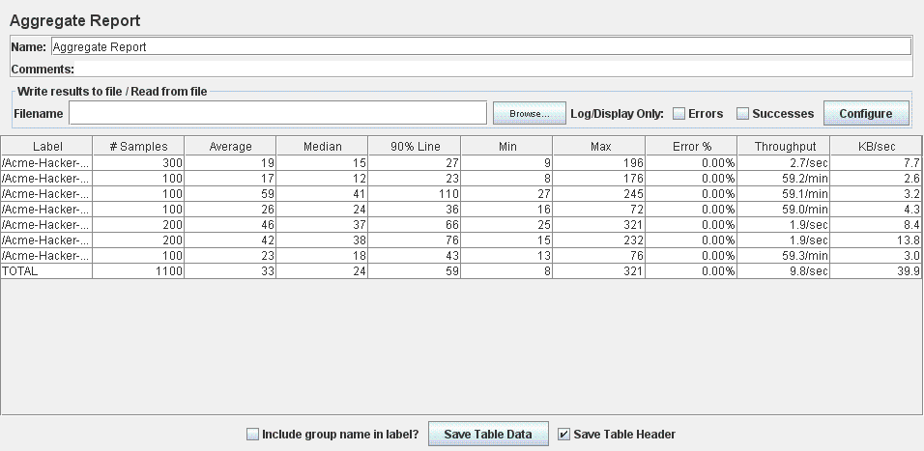

GRAPH RESULT

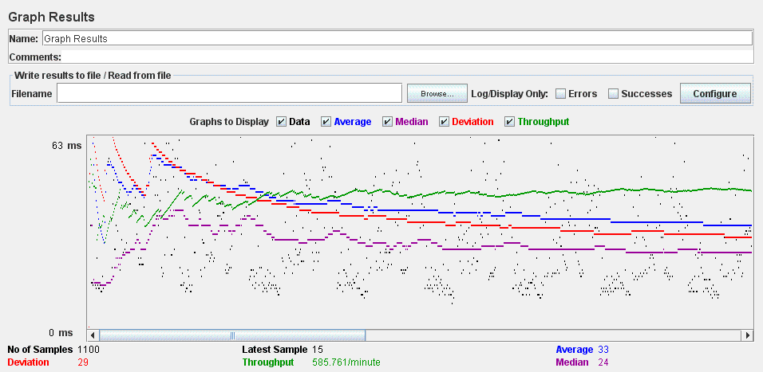

FINDER TEST (UC 17.2)

In this test we performance the search and resut list of a finder. The test consists of 10 threads (user) doing 10 loops, these are the results.

AGGREGATE REPORT

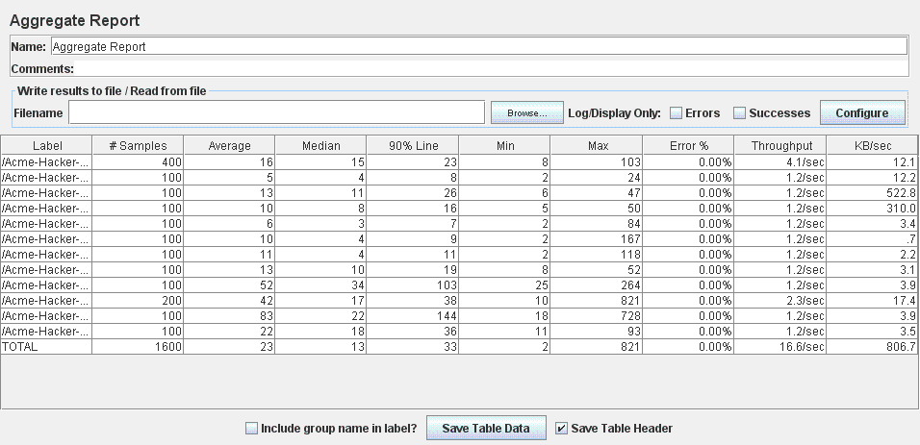

GRAPH RESULT

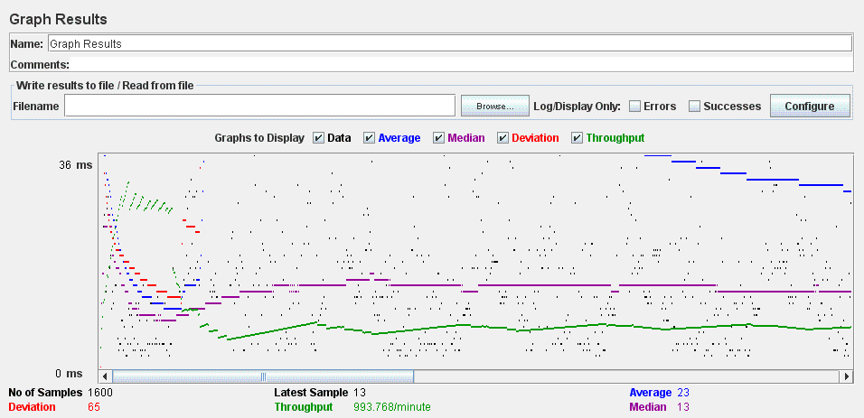

MANAGE ITEM TEST (UC 10.1 – Acme Rookies)

In this test we performance the list, create, update, delete and show of items. The test consists of 10 threads (user) doing 10 loops, these are the results.

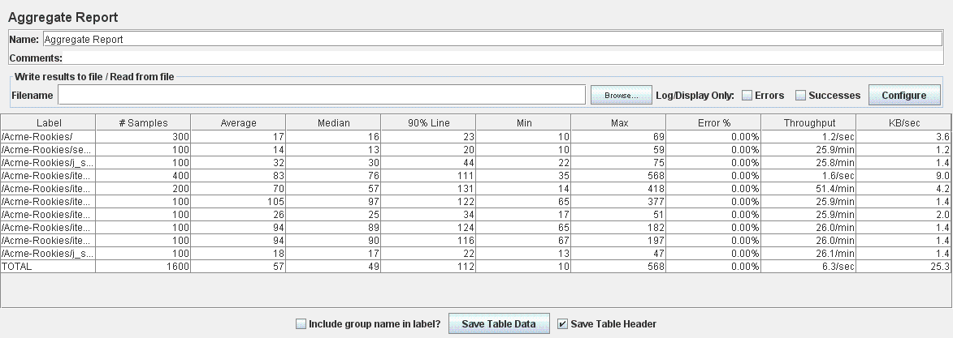AGGREGATE REPORT

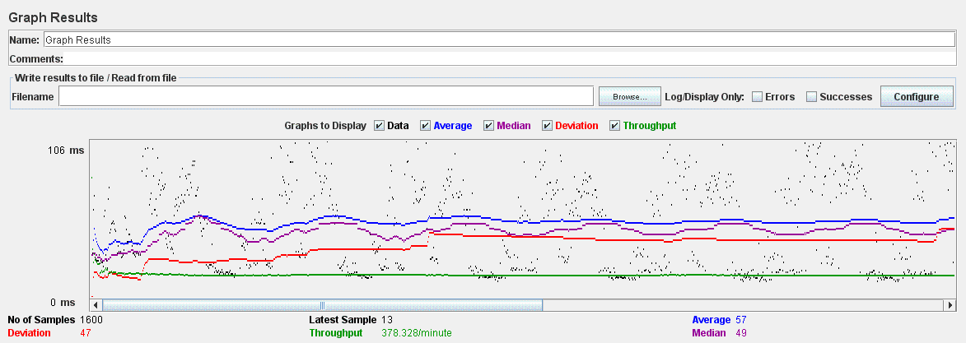GRAPH RESULT

MANAGE SPONSORSHIPS TEST (UC 13.1 – Acme Rookies)

In this test we performance the list, create, update, delete and show of sponsorships. The test consists of 10 threads (user) doing 10 loops, these are the results.

AGGREGATE REPORT

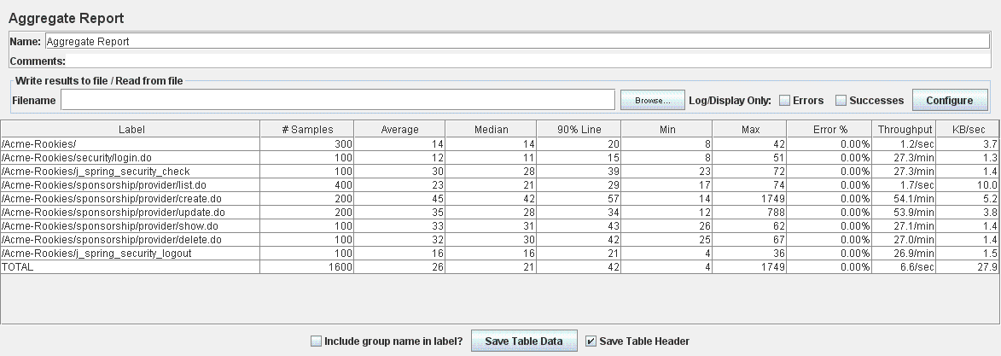

GRAPH RESULT

